Lesson 3
A Fire’s Story

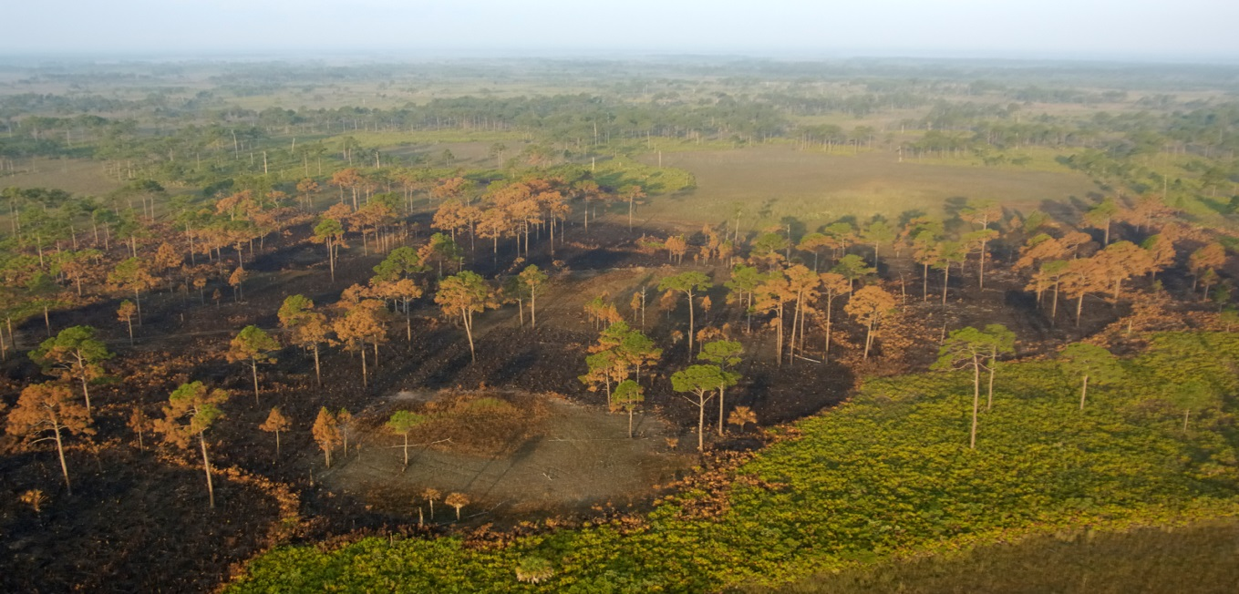

Subjects
Science

Time Estimate
One 40 minute class period

Key Vocabulary
Prescribed fire; Prescribed burn; Adaptation; Habitat; Fire return interval; Fire Regime; Fire intensity

Sunshine State Standards

Science
SC.4.L.17.4Recognize ways plants and animals, including humans, can impact the environment.
SC.4.N.1.1Raise questions about the natural world, use appropriate reference materials that support understanding…
SC.4.N.1.3 Explain that science does not always follow a rigidly defined method ("the scientific method") but that science does involve the use of observations…
SC.4.N.1.4 Attempt reasonable answers to scientific questions and cite evidence in support.

Key Questions

What is the difference between a prescribed and wildland fire? What are the steps land managers and wildland fire fighters take in initiating a prescribed burn? Why does Big Cypress National Preserve have prescribed fires?
Objectives

In this activity, students will:
- Understand they key steps in researching, planning, and implementing a prescribed fire.
- Identify planning, implementing, and monitoring stages of a prescribed burn.
- List three benefits of prescribed burns.
- List at least two things all prescribed burns protect.
Materials

- Student copies of “A Fire’s Story” timeline cards for each group.
- Scissors
- String and clothes pins (optional)
- Colored pencils (for map portion)
- Ruler (for map portion)

Background

Arguably one of the most powerful natural forces; fire shapes, creates, and replenishes the landscape. Historically, fire caused by lightning during the transition from the dry to wet seasons was a regular and frequent occurrence in the prairies and pinelands of South Florida. When natural low intensity fires swept through fire adapted habitats it would benefit the overall health of these environments. Fires help to thin and prune plants, recycle nutrients to the soil, create space for new plants to grow and animals to forage for food. Despite the ecological benefits fire has not always been viewed as a natural and healthy part of the ecosystem. Wildfires were suppressed leading to the accumulation of plant material, ecosystems getting out of balance and the potential for catastrophic and devastating fires.

Today land managers understand and recognize the ecological benefits of fire and work return fire to the environment. This is done by either managing fire caused by lightning or other causes to burn if it is safe and beneficial to do so or setting a prescribed fire. A prescribed fire is defined as a fire set in a skilled manner to achieve specific results in a definite place under exacting weather conditions called parameters. Development of roads and homes in landscapes where fire was a natural part of the environment in South Florida has the potential to threaten life and property. Prescribed fire is an important tool used to protect homes, roads, and property from the effects of a devastating fire. Big Cypress National Preserve has one of the largest Fire and Aviation Management Programs within the National Park Service. Its goal to restore fire regimes within the preserve using prescribed and wildland fire by following a framework outlined in a comprehensive plan – Prescribed burn. This plan identifies firefighter and public safety concerns. The prescribed fires set by Big Cypress Fire Management Division are the culmination of research and careful planning. In order to conduct a prescribed fire, researchers and scientists must first collect data on the area they want to burn, which includes fuel type, distance to roads and structures, as well as the typical fire return interval for that habitat. Data from surrounding areas must be monitored as well in order to increase safety of the burn. A burn plan will be created, complete with maps and weather data. A burn boss assigned to take charge of the burning process. Prior to the set date for the fire, temperature, humidity, and wind speed and direction are monitored; if the weather conditions are not right the day of the scheduled burn, the fire will not be conducted.

Prescribed Fire: Interpreting the Maps

A critical part of the burn plan for a prescribed fire and a wildland fire is the fire map. These maps are consulted and adjusted throughout the process. Maps are created before, during, and after a prescription burn. Before prescribed fires, maps are used to show the desired outcomes like burn mosaics, and areas for treatment. For both prescribed and wildland fires that occur over multiple days, a map will be created for each day of the fire to show its progression or suppression. After a prescribed fire has been completed or a wildland fire that has either gone out naturally or been suppressed, a final map will be created to show the outcome of that fire event as well as information on what areas did and did not burn, acreage, and other important information such as structures, homes, roads, trails, and threatened and endangered species habitat.

Sometimes maps use satellite imaginary to depict the different vegetation covers or a color chart. Regardless of what stage the map is created and whether it is for a wildland fire or prescription burn, every map created by the Big Cypress Fire Crew must contain the following pieces of information: title, legend, scale, coordinates, area of interest, and date created. The fire maps used in this lesson are from a real prescription (RX) fire burn plan. One map was used prior to the prescribed burns. For this map the area that was ultimately treated has been colored to show the different types of habitats within Big Cypress Preserve. On the left side (west) of Highway 29, satellite imaginary has been used and is more representative of the maps used for prescribed fires. Wildland firefighters and fire ecologists are skilled at interpreting the differences in vegetation types from these images. The other map shows five prescribed burns for the Copeland burn area. This map contains information on the dates of the burns and the total acres treated. Students should be able to compare the two maps.

On both maps, the mapmaker placed latitude and longitude readings on the edges of the map in order for the viewer to locate an exact spot within the map boundaries if they so choose. To find the latitude and longitude coordinates for a specific spot, locate the latitude coordinates on the sides of the map. Longitude is found on the top and bottom of the map.
Advance Preparation

- Make a copy of the student worksheet: “A Fire’s Story: Prescribed Fire Timeline Cards” for each student or student groups.
  - If desired, assemble additional construction paper, string, and clothes pins for hanging the timeline cards.
- Project or print colored copies of the “Copeland RX Planning” and “Copeland RX (multi-day)” maps for each student or group of students and one copy of the student worksheet for each student
- Optional, watch a video on prescribed fire at Big Cypress National Preserve.
Procedure
- Ask students to share what they already know about fire in South Florida. Do they think that fire is beneficial or harmful?

- Share with students some information on Big Cypress National Preserve’s prescribed fire program. As one of the largest in the National Park Service, the preserve’s wildland firefighters will conduct approximately 60,000 acres of prescribed burns annually.

- Working alongside National Park Service land managers, resource managers, invasive species specialists, and botanists, wildlife biologists, and ecologists, fire management rangers identify target areas that need to be burned.

- Prescribed burns need expertise and planning. Managers must write extensive prescriptions that include information on weather parameters, public and private properties, threatened and endangered species habitat, equipment and tools, ignition, and most importantly wildland fire fighter safety.

- Ask students if they think that this is an easy or complicated procedure? Can students identify some of the steps that need to be in place before, during, and after a burn?

- Tell students that they will be investigating some of the key steps in implementing a prescribed burn by assembling a fire timeline.

- Students will either work in groups or individually to cut out the 10 steps highlighted in this activity. They will then arrange the steps in the correct order.

- Once students have assembled their timelines review the process.

- If desired these timelines can be glued onto construction paper and hung up in the room.

- Students can also research some of the prescription fires in Big Cypress and write their own timelines.

- Once students have discussed and understand the process of a prescribed burn, it is time to “plan” for a prescription burn in the prairies and pinelands of Big Cypress!

- Students will either work individually or in groups to interpret two maps from a real prescription burn plan within Big Cypress National Preserve.

- Pass out copies of the maps and the worksheets. It may be beneficial to go over the map has a group to help orient students. Share with students that these are real maps used by the wildland firefighters and fire ecologists of Big Cypress National Preserve.

- Starting with the map titled “Copeland RX planning area,” review that RX is an abbreviation for prescription. Explain the difference between how vegetation cover (habitat types) is depicted on this map on the west versus east side of Highway 29.

- Have students create a compass rose for this map using a ruler and place it within the white Big Cypress National Preserve outline.

- Review degrees of latitude and longitude and discuss the precision of how these coordinates are displayed (using degrees, minutes and seconds). Ask students why wildland firefighters and fire ecologists would need to be so exact in their locations.

- Once the compass rose has been created and latitude and longitude discussed, students should be able to answer the worksheet questions.

A Fire’s Story! Prescribed Fire Timeline Cards
Name: _______________________________________
Directions: Cut out the pictures and descriptions below. Place the cards in the correct order starting with the first step fire managers need before a prescription to the desired result:
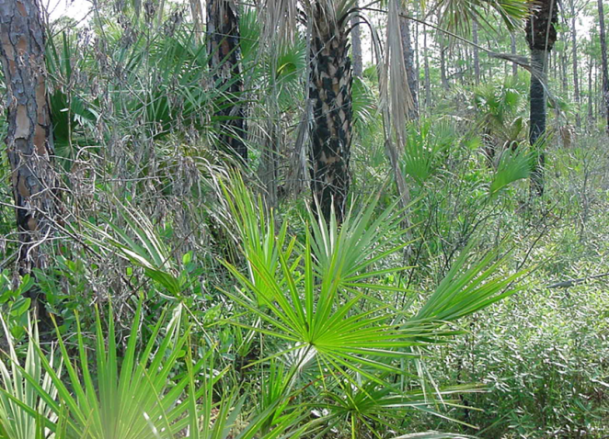
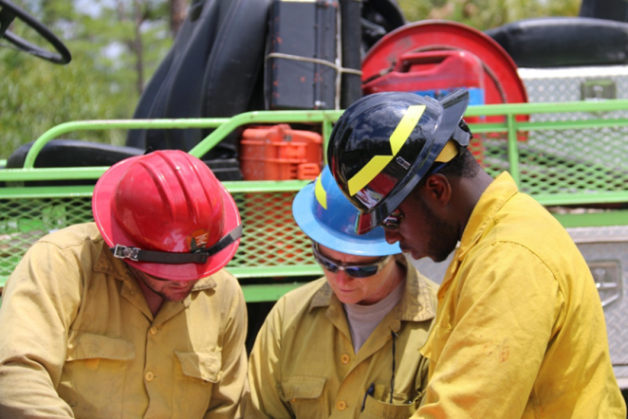
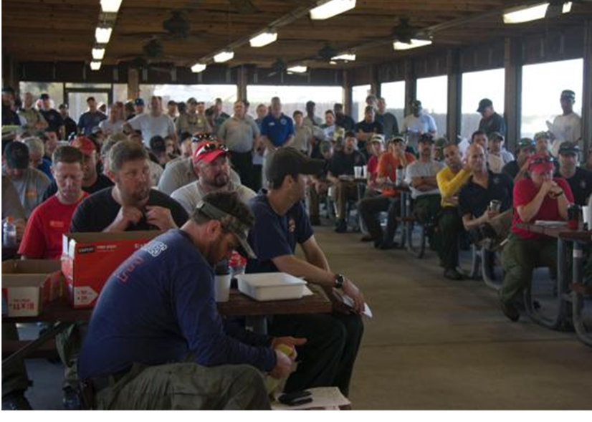
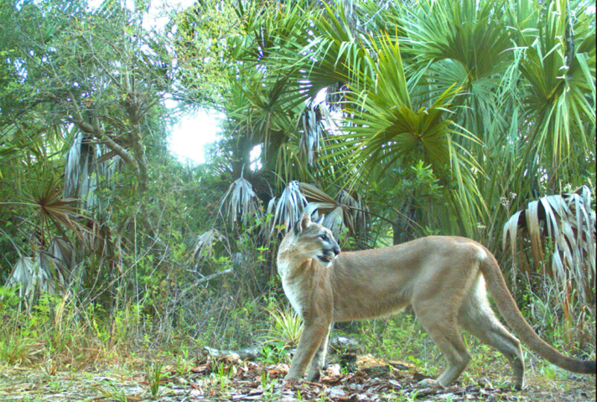
Once areas are identified a prescription is written that includes size of the area to be burned and information such as property, weather, safety, and endangered species. A map of the area is made. Managers and wildland firefighters meet to discuss the plan.
Animals return to their habitats.
An overgrown forest is not as healthy as it could be. Fire ecologists and wildland managers identify areas in need of fire prescriptions.

On the day of the prescription fire the Burn Boss and wildland firefighters review the existing plan, weather, and make any necessary changes to ensure safety.
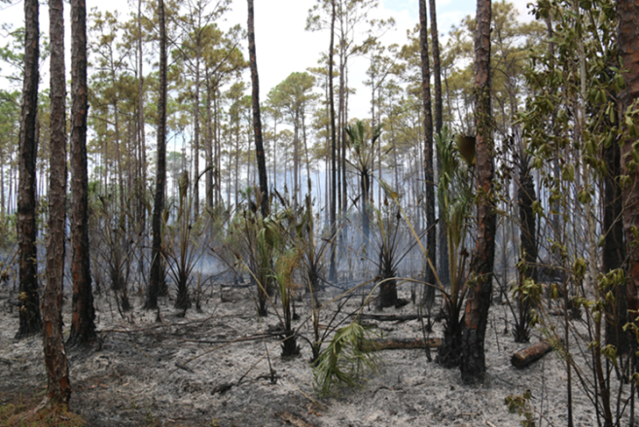
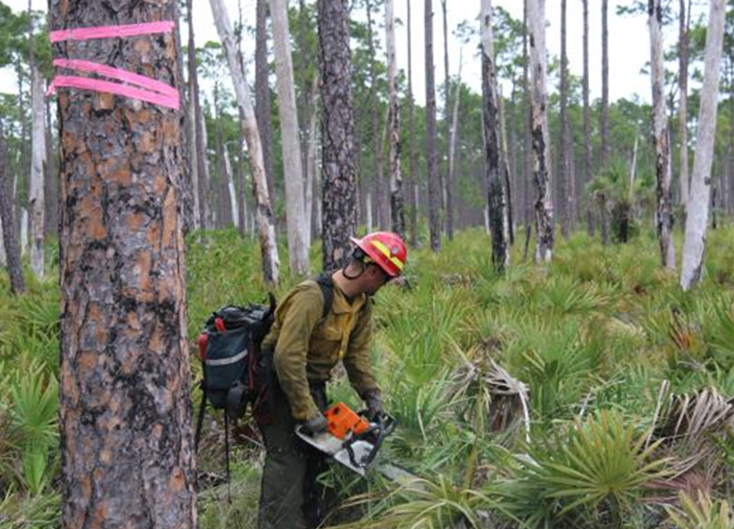
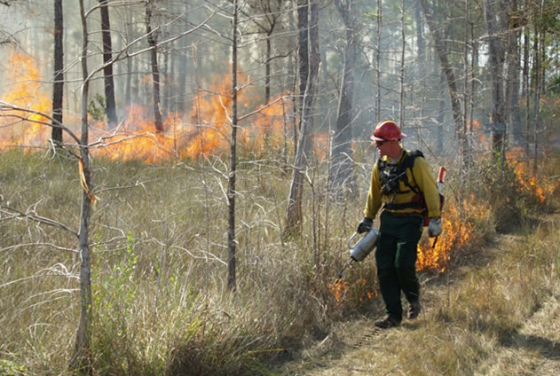
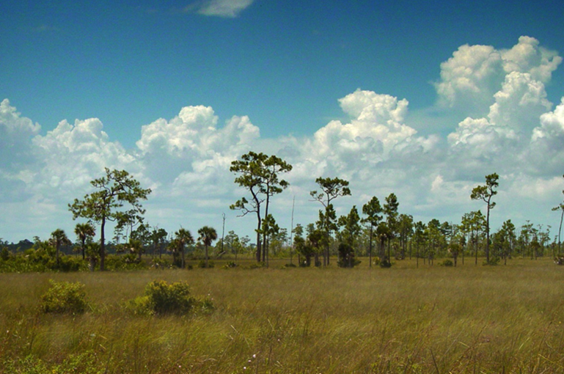
After a prescribed burn, the landscape shows signs of the fire, but is not harmed by it. Overstory trees and palms have charred trunks and green tops.

The endangered Florida Panther and Red-cockaded Woodpecker need habitats that have been burned. Wildland firefighters must ensure that these important shelters are protected by marking important trees and clearing brush before the fire is ignited.
Following the prescription plan, wildland fire fighters will ignite small fires wearing special protective equipment for safety.

Post fire, a healthy habitat provides plenty of food, water, shelter and space for all of the plants and animals that call Big Cypress National Preserve home.

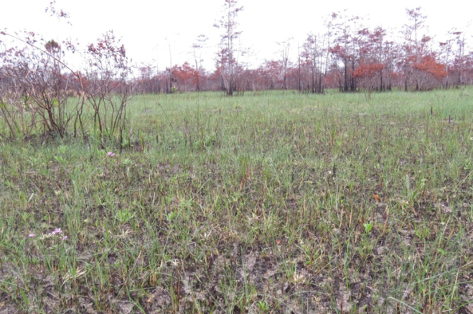
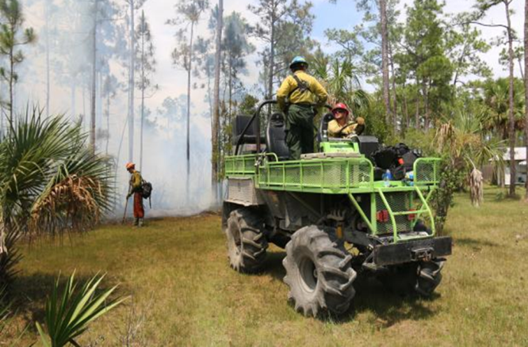
Fire adapted plants quickly regenerate and grow after a fire taking advantage of the newly added nutrients, sunlight, and space.

Wildland fire fighters use special equipment on the ground and in the air to protect homes, roads, and other important resources. The fire is monitored during the burn.

Reading the Maps

Name: ____________________________________________________________________________ Date: _________________________

Directions: Look closely at the two maps provided: “Copeland Rx planning area” and “Copeland RC (multi-day)” and answer the questions below.

Using the “Copeland RX Planning Area Map” answer the following questions:

- Every map created by Big Cypress National Preserve’s Fire and Aviation Department must contain the following pieces of information: Title, Legend, Scale, Area of Interest, Date Created, and coordinates.
  - What is the title of the map? _________________________________________________________________
  - Find the scale. Using a ruler calculate how many inches represents 1 mile.
_________________________________________________________________
  - Locate the legend and answer the following questions:
How many different vegetation (habitat) communities does the map represent?
________________________________________________________________
What do the following symbols represent?
Red Triangle: ________________________________________________________________
Black Square: ________________________________________________________________
- Locate and underline the FOC (Fire Operations Center) on the map. What state highway is the FOC located on?
________________________________________________________________________________________
- List three towns that are shown on the map?
________________________________________________________________________________________
________________________________________________________________________________________
- What is the major habitat type represented on this map?
________________________________________________________________________________________
- The numbers on the top and bottom of the map represent coordinates of longitude. The numbers on the two sides represent coordinates of latitude. Wildland firefighters can use these coordinates to find specific locations or habitat types.
Find 81°20’30”W on the top of the map and draw a line to the 81°20’0”W on the bottom of the map.
Next, find 25°58’0”N on the side of the right map and draw a line to connect it to the 25°58’0”N on the other side of the map.
What habitat is located at the coordinate 81°20’0”W 25°58’0”N? (Hint: It is where the two lines intersect.)
__________________________________________
- Imagine YOU are a wildland firefighter at Big Cypress National Preserve. You want to plan a prescription burn in the prairies and pinelands located south of Lower Wagonwheel Road, east of Highway 29, west of Birdon Road, and north of Highway 41. Shade the prairie habitats and circle the pineland habitats located in this area in preparation for a prescription burn. Draw a rectangle around four areas that you do not want to include in the prescribed burn. Why did you choose these areas?
__________________________________________________________________________________________
__________________________________________________________________________________________
__________________________________________________________________________________________
__________________________________________________________________________________________
__________________________________________________________________________________________

Using the “Copeland RX (multi-day)”map answer the following questions:
The “Copeland RX (multiday)” map is real data taken from a prescription burn over five days. On the map RX is used as an abbreviation for prescribed or prescription burn. Each number represents one fire prescription.

- How many prescribed burns did the area receive?
______________________________________________________________________________________
- When did the Copeland RX burns take place?
______________________________________________________________________________________
- How many acres total were burned?
______________________________________________________________________________________
- Compare the “Copeland RX (multi-day)” map to the “Copeland RX planning area” map. What was the major habitat type that was treated during the prescribed fire?
_______________________________________________________________________________________
- What habitat type was largely unburned?
_______________________________________________________________________________________
- Was there any overlap between areas YOU set aside and the real-life prescription burns? ______________
If so, what areas overlapped?
_______________________________________________________________________________________
_______________________________________________________________________________________
_______________________________________________________________________________________
_______________________________________________________________________________________
_______________________________________________________________________________________

A Fire’s Story! Teacher Answer Sheet
The Timeline Cards below are shown in the correct order:
The endangered Florida Panther and Red-cockaded Woodpecker need habitats that have been burned. Wildland firefighters must ensure that these important shelters are protected by marking important trees and clearing brush before the fire is ignited.

Once areas are identified a prescription is written that includes size of the area to be burned and information such as property, weather, safety, and endangered species. A map of the area is made. Managers and wildland firefighters meet to discuss the plan.

On the day of the prescription fire the Burn Boss and wildland firefighters review the existing plan, weather, and make any necessary changes to ensure safety.
An overgrown forest is not as healthy as it could be. Fire ecologists and wildland managers identify areas in need of fire prescriptions.

After a prescribed burn, the landscape shows signs of the fire, but is not harmed by it. Overstory trees and palms have charred trunks and green tops.

Following the prescription plan, wildland fire fighters will ignite small fires wearing special protective equipment for safety.

Wildland fire fighters use special equipment on the ground and in the air to protect homes, roads, and other important resources. The fire is monitored during the burn.

Fire adapted plants quickly regenerate and grow after a fire taking advantage of the newly added nutrients, sunlight, and space.
Post fire, a healthy habitat provides plenty of food, water, shelter and space for all of the plants and animals that call Big Cypress National Preserve home.

Animals return to their habitats.

Reading the Maps Teacher Answer Sheet

Directions: Look closely at the two maps provided: “Copeland Rx planning area” and “Copeland RC (multi-day)” and answer the questions below.

Using the “Copeland RX Planning Area Map” answer the following questions:

- Every map created by Big Cypress National Preserve’s Fire and Aviation Department must contain the following pieces of information: Title, Legend, Scale, Area of Interest, Date Created, and coordinates.
  - What is the title of the map?
Copeland RX Planning Area
  - Find the scale. Using a ruler calculate how many inches represents 1 mile.
1 5/16th of an inch
  - Locate the legend and answer the following questions:
How many different vegetation (habitat) communities does the map represent?
10 habitats
What do the following symbols represent?
Red Triangle: Private Structures
Black Square: NPS Property
- Locate and underline the FOC (Fire Operations Center) on the map. What state highway is the FOC located on?
Highway 29
- List three towns shown on the map?
Lee Cypress, Carnestown, Copeland, Ochopee
- What is the major habitat type represented on this map?
Prairie
- The numbers on the top and bottom of the map represent coordinates of longitude. The numbers on the two sides represent coordinates of latitude. Wildland firefighters can use these coordinates to find specific locations or habitat types.
Find 81°20’30”W on the top of the map and draw a line to the 81°20’0”W on the bottom of the map.
Next, find 25°58’0”N on the right side of the map and draw a line to connect it to the 25°58’0”N on the other side of the map.
What habitat is located at the coordinate 81°20’0”W 25°58’0”N? (Hint: It is where the two lines intersect.)
Prairie
- Imagine YOU are a wildland firefighter at Big Cypress National Preserve. You want to plan a prescription burn in the prairies and pinelands located south of Lower Wagonwheel Road, east of Highway 29, west of Birdon Road, and north of Highway 41. Shade the prairie habitats and circle the pineland habitats located in this area in preparation for a prescription burn. Draw a rectangle around four areas that you do not want to include in the prescribed burn. Why did you choose these areas?
Answers may vary. I choose to not burn the large cypress strands as they do not like to have frequent fires. I also choose not to burn around the houses on Birdon Road and Highway 29.

Using the “Copeland RX (multi-day)”map answer the following questions:
The “Copeland RX (multiday)” map is real data taken from a prescription burn over five days. On the map RX is used as an abbreviation for prescribed or prescription burn. Each number represents one fire prescription.

- How many prescribed burns did the area receive?
Five.
- When did the Copeland RX burns take place?
February 17th to 24th, 2015
- How many acres total were burned?
5,446 acres
- Compare the “Copeland RX (multi-day)” map to the “Copeland RX planning area” map. What was the major habitat type that was treated during the prescribed fire?
Prairies
- What habitat type was largely unburned?
Swamp forest
- Was there any overlap between areas YOU set aside and the real-life prescription burns? Yes (Answers may vary)
If so, what areas overlapped?
Yes, I saw that the large areas of Cypress Forest was not treated and the areas with lots of buildings including houses.

